SKG Jukebox User Manual
Copyright 2010 by Th Skeptical Geek. Thanks to the Salmon King for the original inspiration.

Welcome
Welcome to the SKG Jukebox, the all in one, open source, multi-platform music solution. The SKG Jukebox is designed to be the only music program you need for your home game room, HTPC, dorm room computer, or even your netbook. The SKG Jukebox features:
- Easy to use touchscreen friendly interface.
- Full keyboard support. Press any letter key to go to the first artist beginning with that letter. Advanced options can be accessed with simple key combinations. (Ctrl-A for Album Art, etc)
- Support for multiple file formats. MP3 and wav are supported, as well as open formats like ogg vorbis and flac.
- Custom album lists. Every member of the family can have SKG Jukebox display only the albums they want to choose from Kids don't have to scroll through all of Dad's “old guy” music. Parents don't have to scroll through their kids' “tween crap.”
- Playlists. Because every other music program has them.
- Integrated CD ripper. Rip your CDs to mp3s, ogg or flac files.
- Integrated album art downloader.
- Special netbook mode, designed to be easier to use on smaller screens.

Introduction
So, who is The Skeptical Geek, and why did he feel the need to write a jukebox program? I am a professional software developer, living somewhere in the US southwest. One day, a few years ago, I was seized by the irrational desire to buy a condo. I ended up with a large den, which wasn't being used for anything, so I turned it into a home game room. I put in a MAME cabinet, a pinball machine, a 70s Cavalier Coke machine, and a candy machine. All that was missing was music.

I originally wanted one of those Wurlitzer bubble CD jukeboxes, but at around $6,000, they were about $5,900 out of my price range. So I started thinking about a computer based solution. As a die hard geek, who has built dozens of PCs over the years, I had more than enough spare parts to build a simple system for storing and playing music. A quick Ebay search got me an inexpensive touchscreen monitor. What I needed now was a game room style jukebox program.

I went to the forums at www.arcadecontrols.com I found information on a lot of different jukebox programs, and tried several. I settled on one called SK Jukebox, from a forum member called Salmon King. It's a great program, and I highly recommend it. But it had some shortcomings. The UI wasn't as touchscreen friendly as I would have liked. And I didn't like the fact that I had to leave the jukebox and go to another program in order to rip a CD or download album art. And it was written in Visual Basic, so was tied to Windows, and I have been a Linux and open source guy for years. The Salmon King abandoned his project shortly after I discovered it, so I decided to roll my own. I wanted to duplicate the basic look and feel of SK Jukebox, but address some of the flaws. Thus was born the SKG Jukebox. The name is both an homage to the Salmon King, and a statement of my identity, SKG being short for Skeptical Geek.

Running SKG Jukebox for the first time
When you run SKG Jukebox for the first time, you will see the screen below.

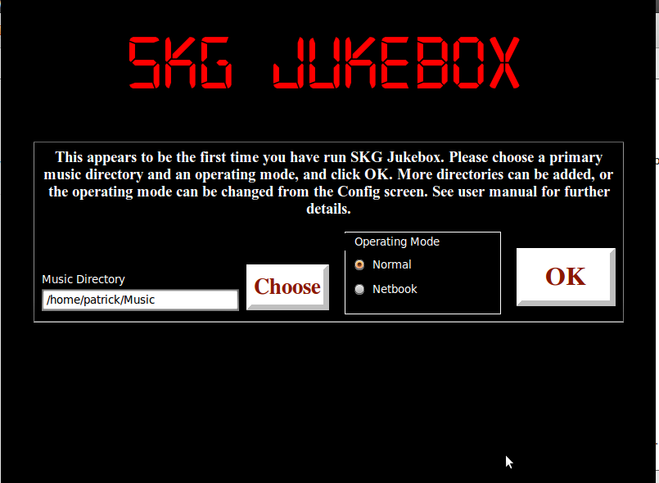
You need to specify a directory where your music is, as well as telling it whether you want to run in normal, or netbook mode. Normal mode displays 4 albums per screen, netbook mode displays 2. Other than that, they are functionally equivalent. The intro screen will default to normal mode, and your OS's default location for music files (/home/username/Music for Linux systems generally, and MyMusic fo Windows systems).

Keep in mind, SKG Jukebox is an album level jukebox. It expects that your music files will be organized a certain way. One, or more, top level music directories (The intro screen allows you to specify one. You can add more late on from the config screen. See the chapter on Configuration Options). The top level directories will contain subdirectories for artists. Each artist directory will contain subdirectories for each album. The album directory will contain the individual track files, as well as, optionally, the album art.

After you choose a music directory and operating mode, SKG Jukebox will start.

The Main Screen
After SKG Jukebox starts, you will see one of the two screens below. If you are running in netbook mode, you will see something like this:

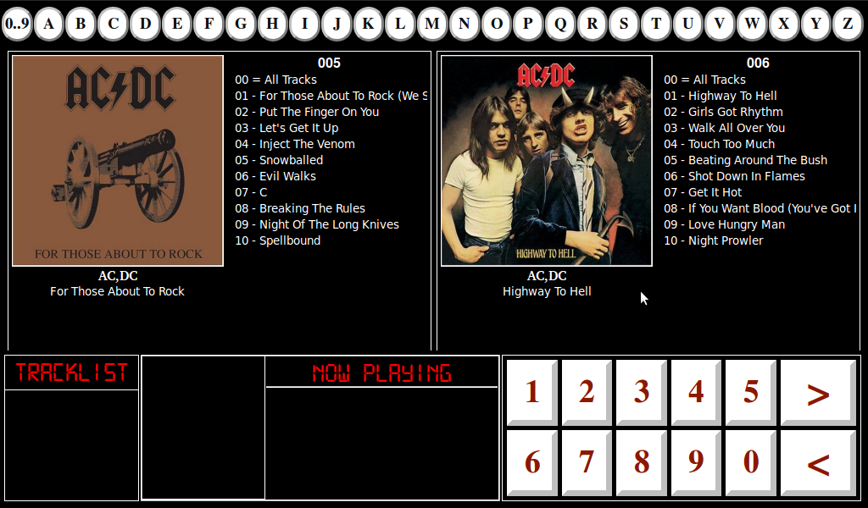

If you are running in normal mode, it will look like this:

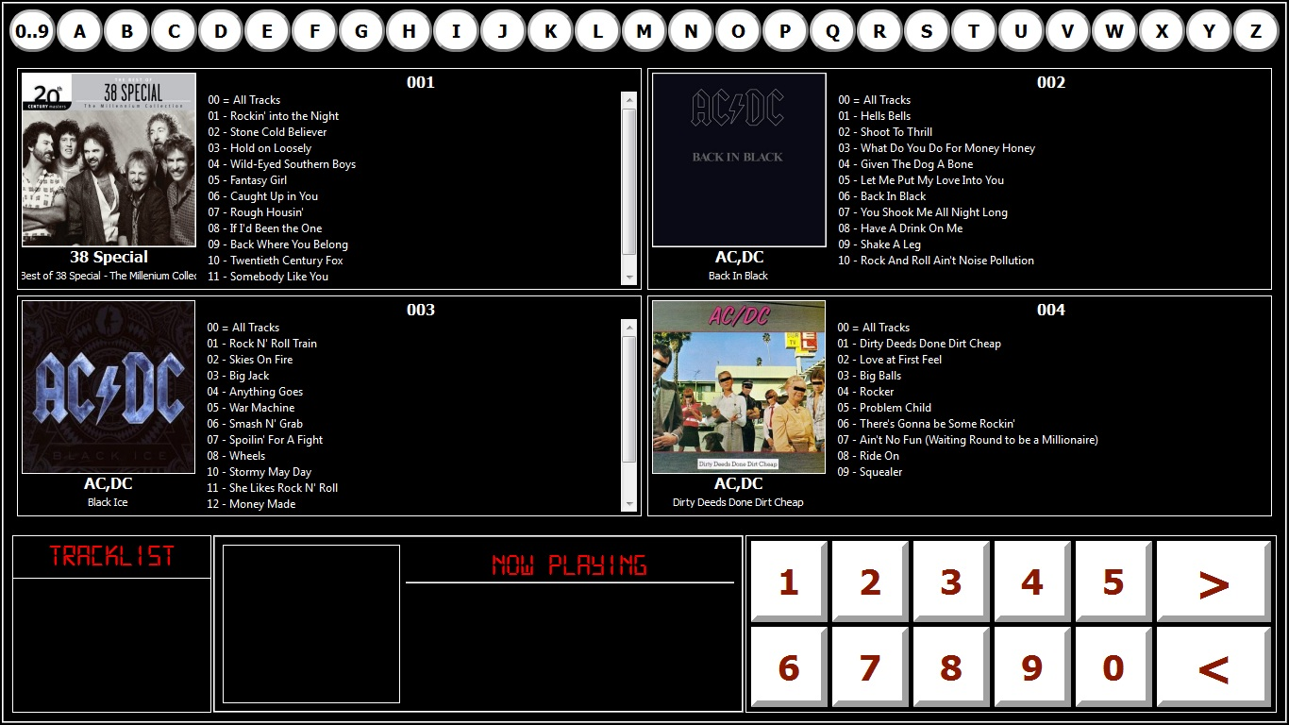

So, what are we looking at here? The most prominent part of the display are the album panels, either 2 or 4 of them, depending on your operating mode. On the left side of the panel are the album art, if available, and underneath that are the artist and album names. On the right side of the panel are the album number and list of tracks.

Album number, you say? Yes. When SKG Jukebox loads your music library, it arranges your albums alphabetically by artist name, and within an individual artist, alphabetically by album name. Artists whose names begin with a number will appear first, before those whose names begin with “A”. SKG Jukebox then assigns each album a number, from 1 to however many albums are in your library, up to 999.

On the top of the screen, you will see a series of round buttons. The leftmost one has a caption of “0..9” and the others all have a caption of a single letter. Pressing one of those buttons will immediately take you to the panel of the first artist whose name begins with that letter. More on that in the section on Navigating through Your Albums.

Underneath the album panels, on the left side, you will see the Track List. This lists the track numbers for all the tracks in the queue. Clicking on this will bring up the Track List form. See the chapter on Managing your Track List.

To the right of the track list is information on the currently running track. It shows a small version of the album art, the artist, album and track names, and the current and total running times. Here is an example of the main screen, with a track playing and several more in the queue.

Netbook Mode
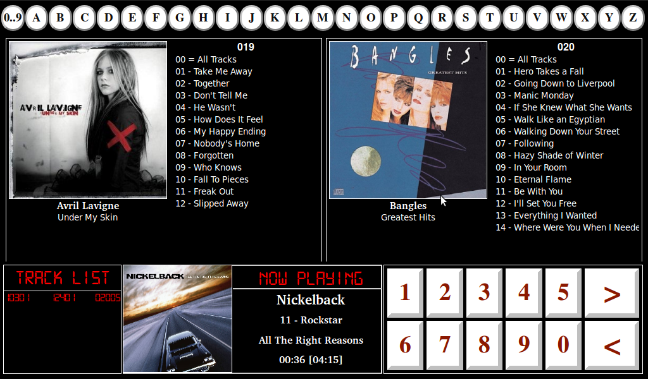

and Normal Mode

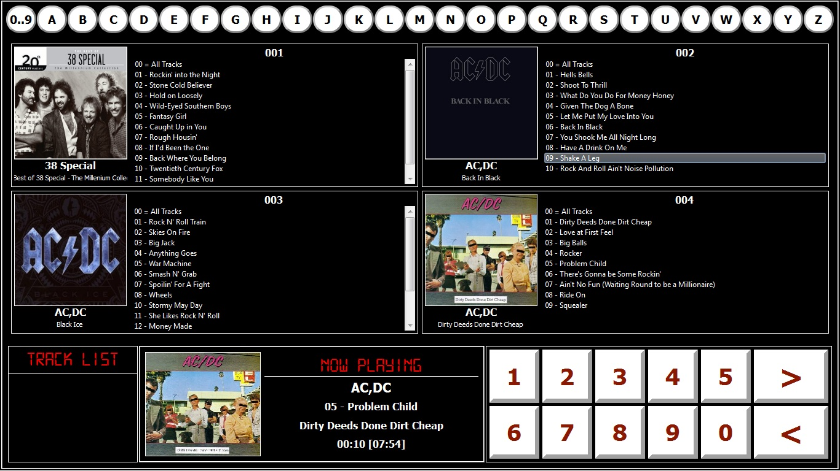

To the right of the current track information are a number of buttons. The numbered ones can be used to select an album and track by number. (See the chapter on Adding Tracks to List) The left and right arrow buttons can be used to scroll forward and backward through your collection, 2 (Netbook Mode) or 4 (Normal Mode) albums at a time.

Navigating Through Your Albums
There are several ways to navigate though your album collection. The simplest is to use the left and right arrow buttons. Click on the buttons, or touch them if using a touchscreen. You can also use the left and right arrow buttons on your keyboard, or whatever keys you have those mapped to (See the chapter on Key Mapping).

Clicking on the left or right button will allow you to navigate backward or forward through your albums, 2 or 4 at a time, depending on the Operating Mode. If going forward through your collection, you will see the next album panel slide in from the left to replace the current one. If going backward, you will see the current one slide away to the right, revealing the previous one.

Navigating through a large collection 2 or 4 albums at a time can get tedious. That's where the round buttons at the top of the screen come in. Clicking or touching one of those will immediately take you to the panel where the first artist with that name is located. Let's say for example, that you are in the “B” section looking at your Beatles albums, and you want to go to Queen. Instead of hitting th left arrow key a bazillion times, just click on the “Q” button. The panel with the first Queen album will slide in from the left, and Viola!, you are in the “Q” section. The lettered buttons can also be clicked by pressing the corresponding key on the keyboard, the tilde (~) key filling in for “0..9”.

Finally, if you know the exact album number you want, you can use the numbered buttons on the main screen. These also correspond to the number keys on the keyboard. Keying in the 3 digit album number will immediately bring up the Select Track screen.

Selecting an Album and Track(s)
There are two ways to select a specific album from your collection. The first is to click/touch the panel containing the album on the main screen. The second is to enter the 3 digit album number, either with the keyboard, or by clicking the letter buttons on the bottom right. The panel containing that album will expand to fill the entire upper part of the screen. See screenshot below:

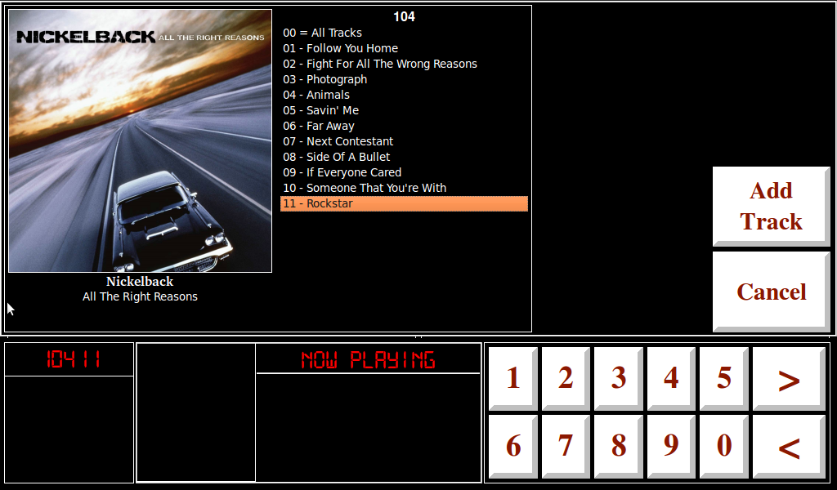

Now that you have selected the album you need to select the track. Either highlight the appropriate track number, or enter the 2 digit track number via keyboard/number buttons. Then, either click the “Add Track” button, or hit Enter on the keyboard. If there are no tracks currently playing, the selected track will start playing right away. Otherwise, the track will be added to the track list. If you look carefully, you will see the first track listed for any album as “00 – All Tracks”. Choosing this will load every track in the album into the list, playing the first one immediately if no track is currently playing.

Managing Your Track List
SKG Jukebox has several options for managing the tracks in your queue. Click/press on the track list in the bottom left of the main screen, or press Ctrl-T on the keyboard to bring up the Track List Screen. You will see something like this:

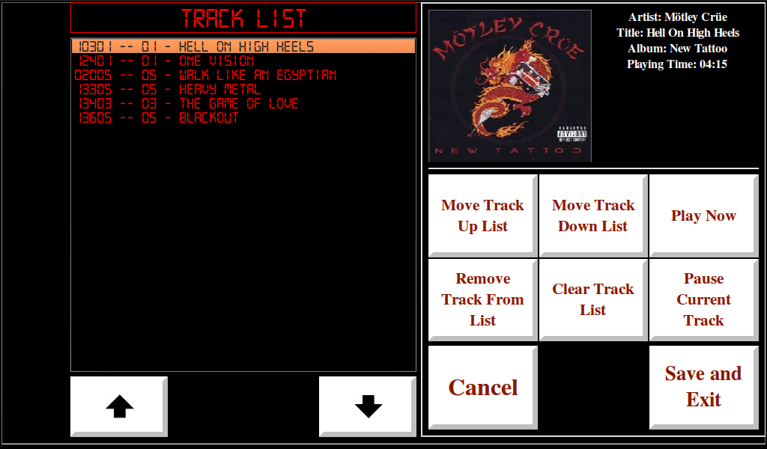
Use the up and down arrow keys to navigate through the list. As you highlight an individual track in the list, you will see some track info in the upper right corner. Below that you will see a number of buttons.
- The Move Track Up and Move Track Down List buttons change the order of the highlighted track in the list. For example, if you highlight track 3, and click the Move Track Down List button, track 3 will become track 4 and vice versa.
- Remove Track From List deletes the highlighted track from the list.
- Clear Track List removes all tracks from the list, including the current playing track.
- Play Now moves the highlighted track to the front of the queue, and starts playing it immediately.
- Pause Current Track pauses playback of the current track. Pressing it again resumes playback.
- Cancel undoes all changes, except for Play Now.
- Save and Exit commits all changes and goes back to the main screen.

The Options Screen
All of the advanced features of the SKG Jukebox can be accessed via the Options screen. Enter album number of "000", either with the keyboard, or the numbered buttons on the main screen. Alternatively, you can press Ctrl-O on the keyboard (Ctrl and the letter "O", not the Number 0). You will see the following screen:

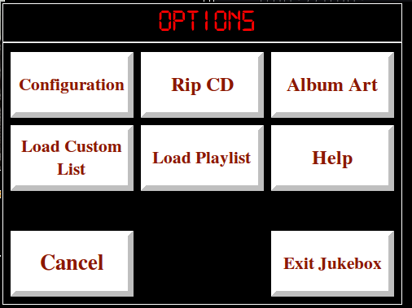

The buttons on this screen should be pretty self-explanatory. See the chapters on each individual screen for more details.

The Configuration Screen
Access the Configuration screen from the Configuration button on the Options screen, or by hitting Ctrl-G on the keyboard from the main screen. This screen has 4 parts.

General
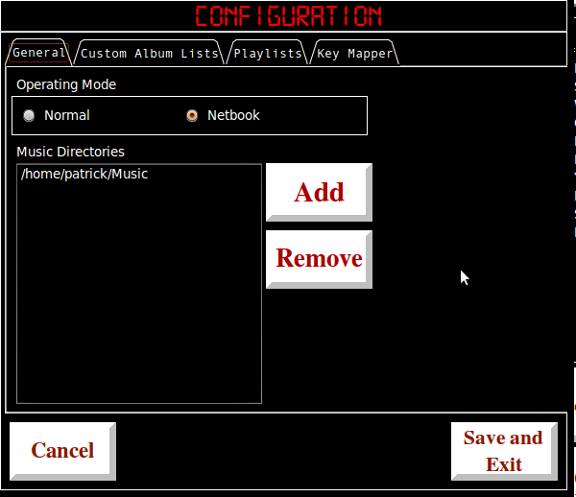
From here you can add or remove top level muic directories, and change the operating mode. These settings are stored in a plain text file called "Config.txt, in the reources subdirectory.

Custom Album Lists
For more information, see the chapter on Custom Album Lists.

Playlists
For more information, see the chapter on Playlists.

Key Mapper
SKG Jukebox comes with full keyboard support. However, the Skeptical Geek realizes that not everyone who uses the jukebox will be doing so with so with a standard keyboard. Some will be using it in a cabinet, using an I-Pac or similar keyboard encoder. Hence, the Key Mapper.

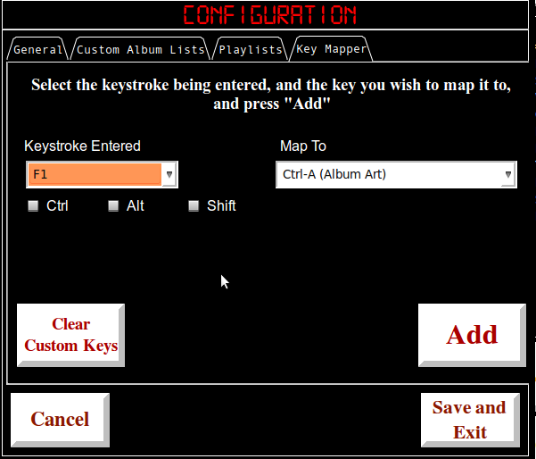
The operation here is fairly simple. On the left side, choose the key that is actually being pressed, from the drop down list. If the Ctrl, Alt, or Shift keys are also part of the key press, check the corresponding boxes. On the right side, choose the keystroke that you want it maaped to, from the right side drop down list, then click Add. The settings are stored in the CustomKeys.xml file, in the resources subdirectory. Hit Clear Custom Keys to clear all key mappings and delete the Custom Keys file.

Save and Exit and Cancel Buttons
Any changes made in the configuration screen need to be confirmed with the Save and Exit button. This writes all changes to the appropriate files, reloads the configuration, and brings you back to the main screen. The Cancel button undoes all changes, and reverts back to the main screen.

Custom Album Lists
Are you a little bit country, and your spouse a little bit rock and roll? Do you hate your childrens' taste in music, and vice versa? Would you like to show off the SKG Jukebox at your next party, but don't want your friends to know you're secretly a Britney Spears fan? Then Custom Album Lists are for you!

Custom Album lists are a way to get the SKG Jukebox to display only a subset of the albums in your collection, instead of everything. Basically, you create a list, specify which albums you want in it, then load it. As far as SKG Jukebox is concerned, your entire library now consists of only those albums you specified in your list. You can create custom lists for each family member, different list for different types of get togethers, etc. Fist, let's walk through how to create one.

Creating a Custom Album List
First, bring up the Configuration screen, and go the Custom Album List section.

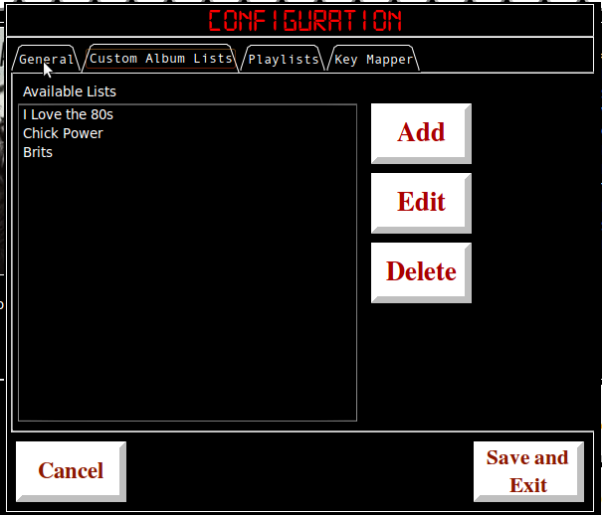
Click the Add button to get to the Add/Edit Custom List screen.
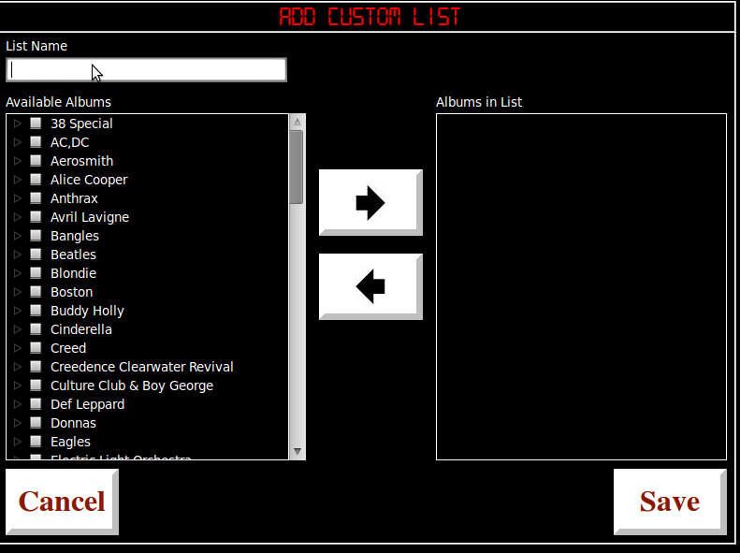

Give the list a name
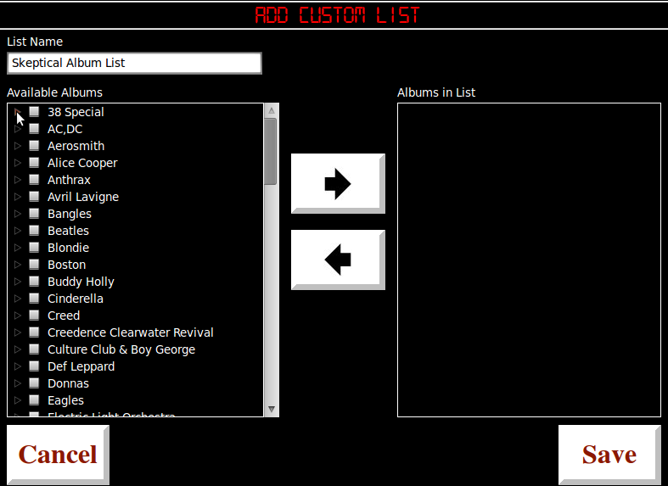
Expand the artist entries, to get to the individual albums. Check on the ones you want, then click on the right facing arrow button to add them to the list.

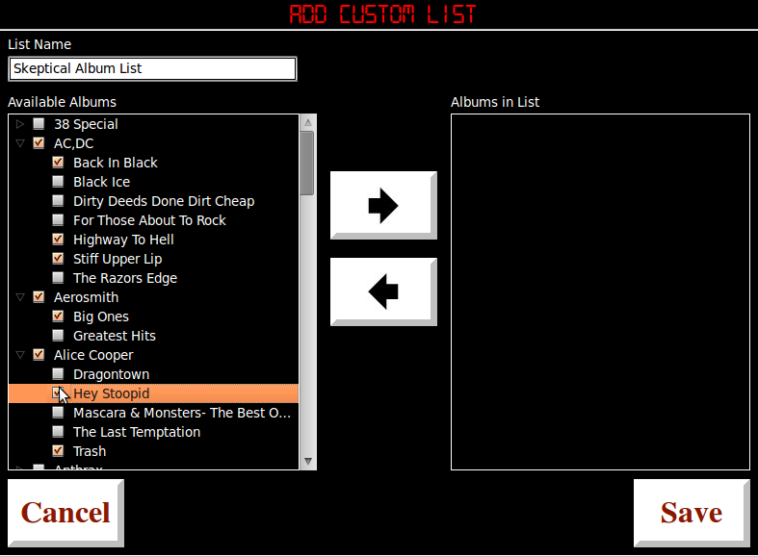

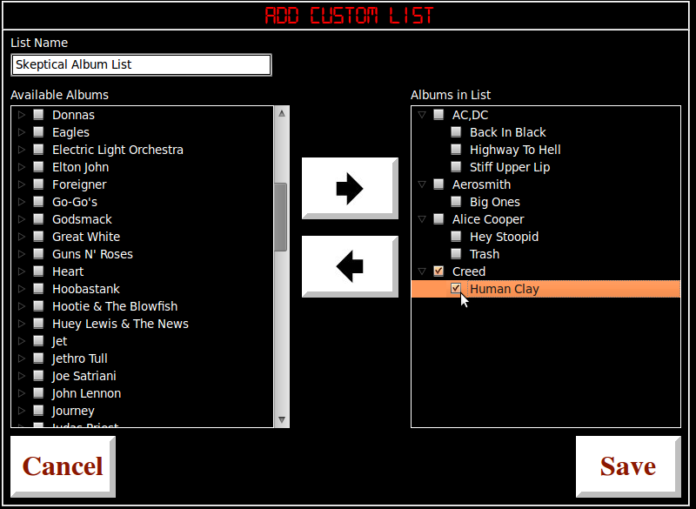

Mad a mistake? Check the album you don't want in the right hand list, then click the left facing arrow button to return it to the available albums list.

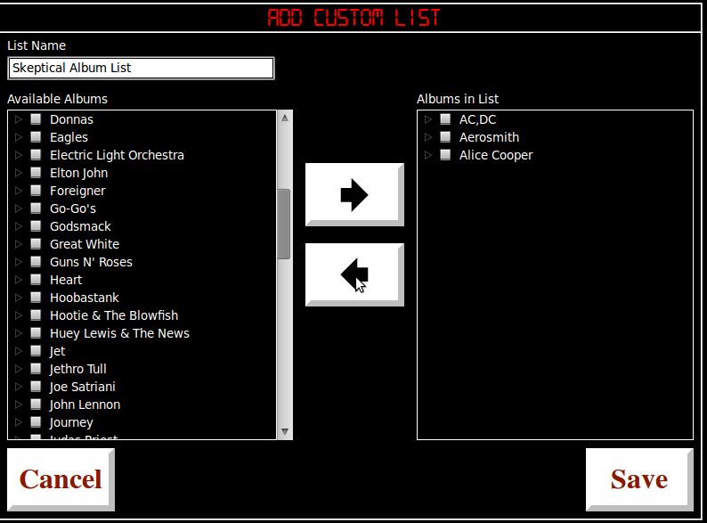
When you are satisfied, click the Save button. The new album list appears in the Custom Album List section of the Configuration screen.

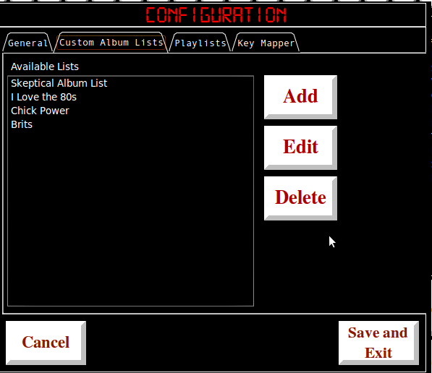
Remember to click Save and Exit, else your custom list will be erased.

Editing a Custom Album List
To Edit a Custom Album List, highlight it and click Edit.

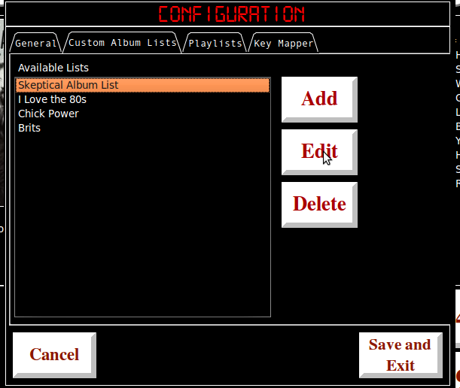
Add and remove albums as if you were creating a new list. When finished, click Save.

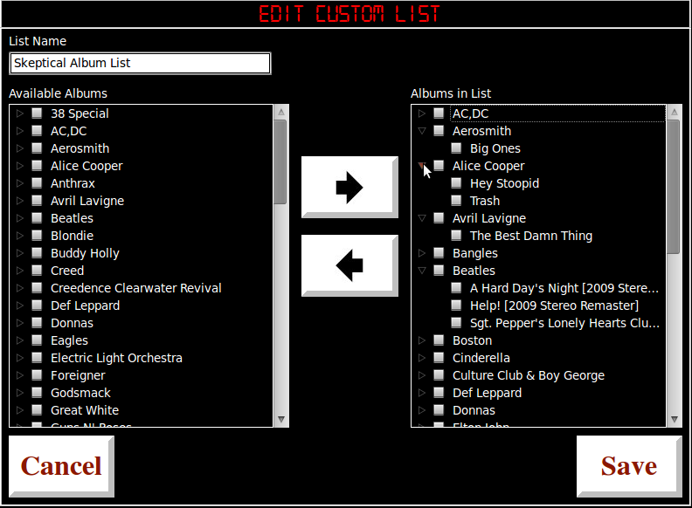
Remember to click Save and Exit when finished.

Deleting a Custom Album List
To delete a Custom Album List, highlight it and click Delete. A dialog ox will pop up to ask if you are sure.

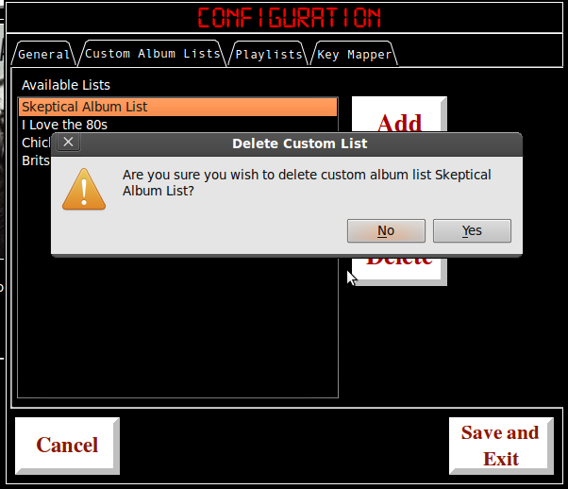
As always, remember to click Save and Exit.

Loading a Custom Album List
To load a Custom Album List, choose Load Custom List from the Configuration screen, or press Ctrl-L from the main screen. This will bring up the Load Custom List screen.

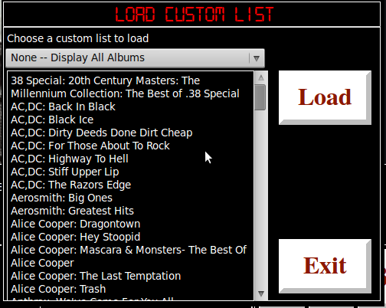

Choost the list you wanr from the drop down list.

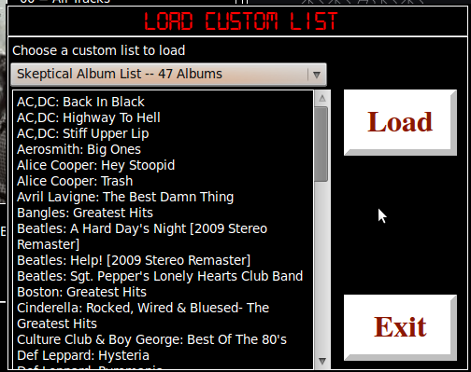

The albums in that list will appear in the list underneath. This is just for reference, so you know you have the correct list. Then click the Load button. A dialog box will pop up asking you to confirm, and warning you that your existing track list will be cleared. This is necessary, since a track list is just a list of track numbers, and the track numbers will all change once the Custom Album List is loaded. The custom list will then be loaded, and the main screen will change and the albums renumbered accordingly.

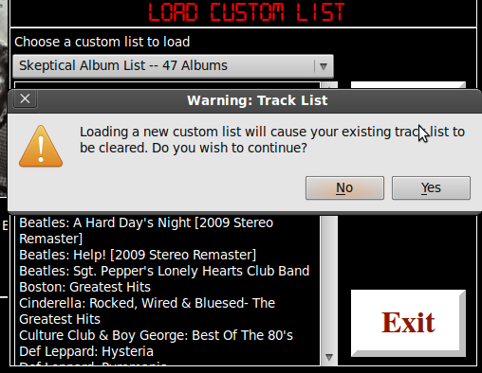

Before loading Skeptical Album List

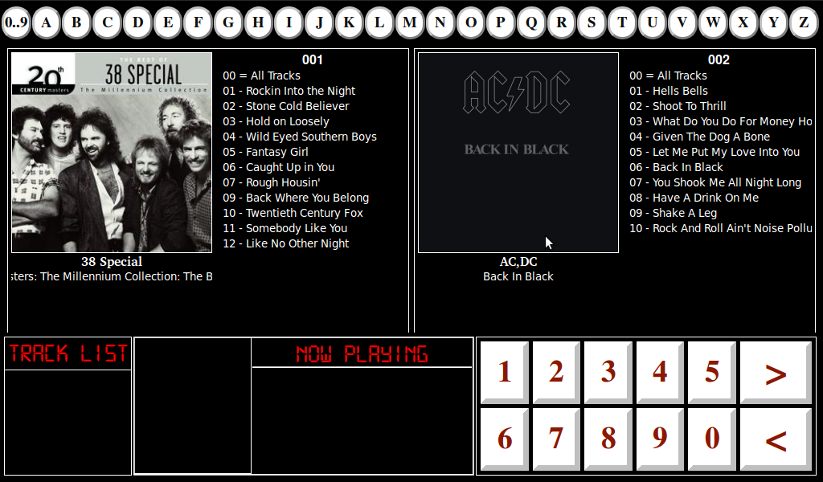

After

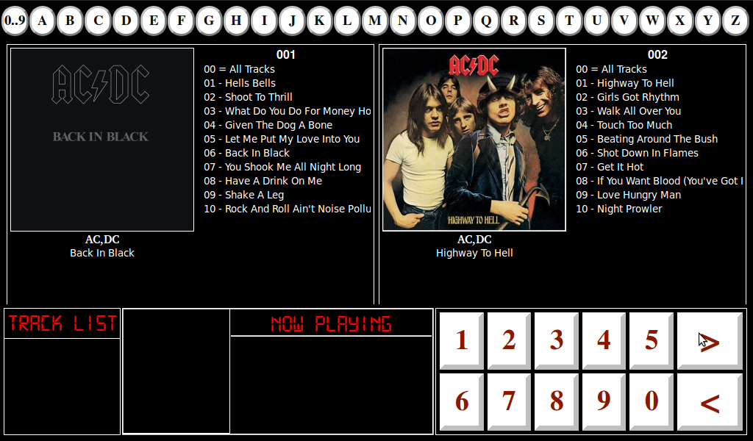
Playlists
Do you have a list of favorite songs you like to listen to while working out, cleaning house, or having a party? With Playlists, you can load all of the into SKG Jukebox in one easy step. Playlists work similarly to Custom Album Lists. You create one, give it a name, add inidvidual tracks, and save it. Then, you load it from the Options screen, and the songs are all added to the track queue.

Creating a Playlist
To create a new playlist, go to the Playlist section of the Configuration screen, and click the Add button.

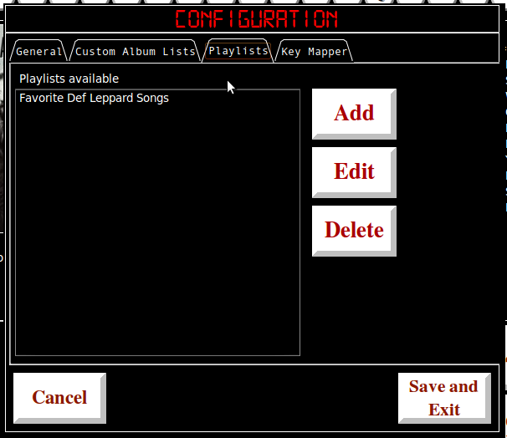

This will bring up the Add/Edit Playlist screen.

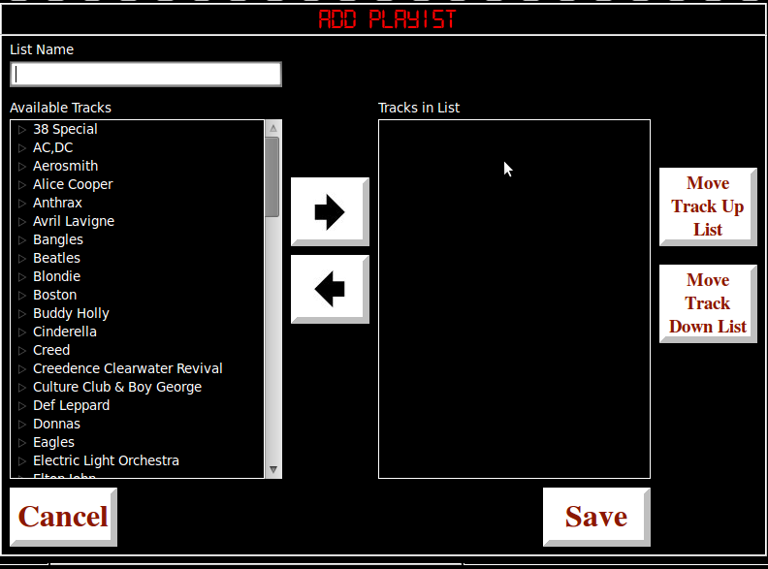

Give the list a name.

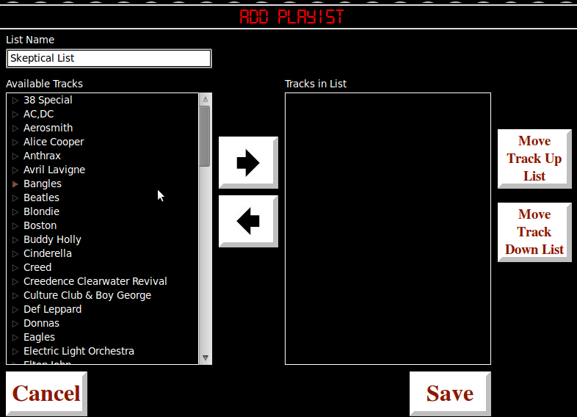

Expand the artist and album entries in the tree on the right. Check the tracks you want to add to the playlist, and click the right arrow button. To remove tracks from the list, check the track in the list on the right, and click the left arrow button.

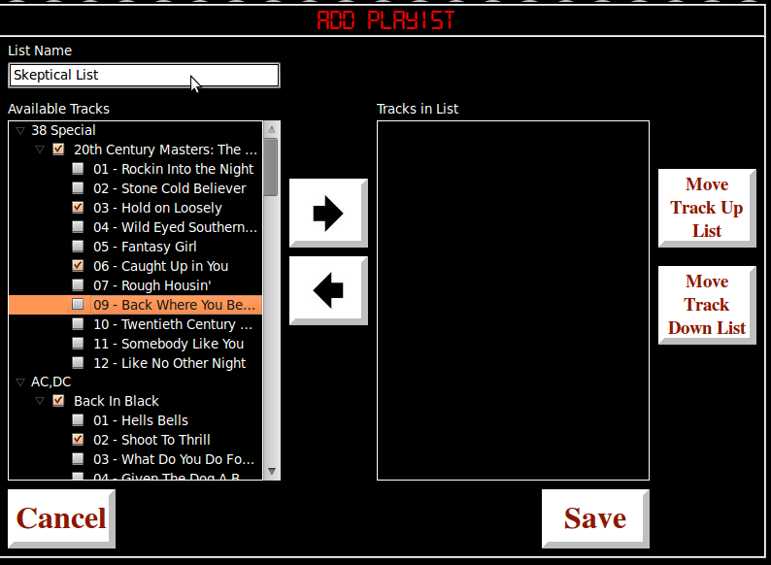

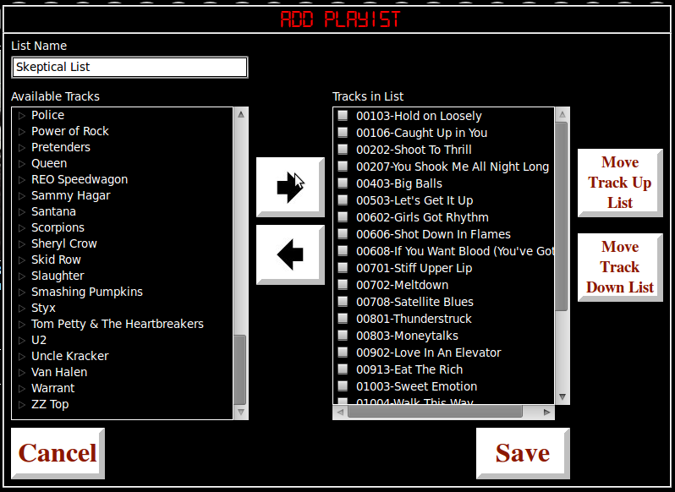

You can change the position of a track in the list, with the Move Up and Down buttons. Highlight the track whose position you want to change, and click one of the two buttons. Keep doing this until the tracks are in the order you want, then click Save.

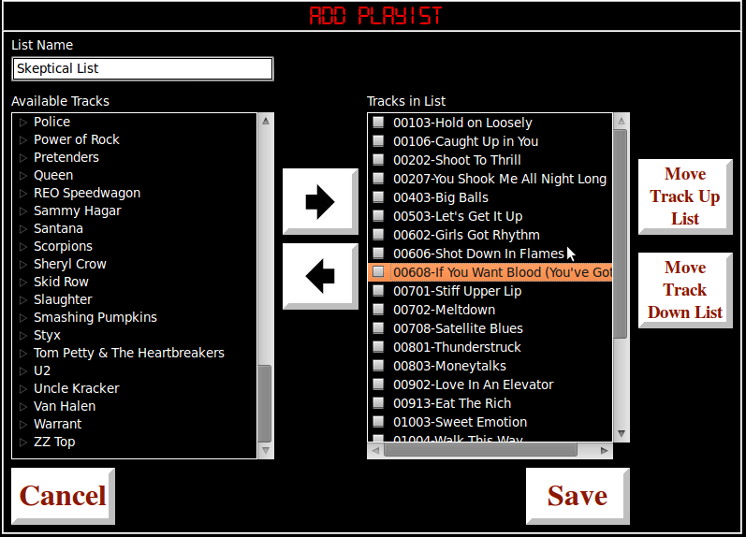
See how the position of the highlighted track changes after clicking the Move Up button.

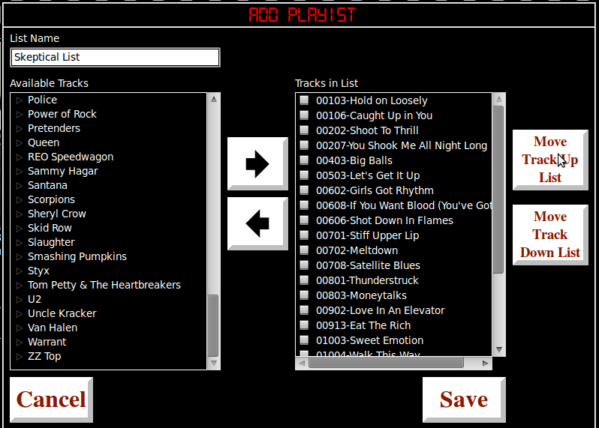

Your playlist is now in Config Screen. Remember to click Save and Exit to write the Playlist to the playlists file in the resources directory.

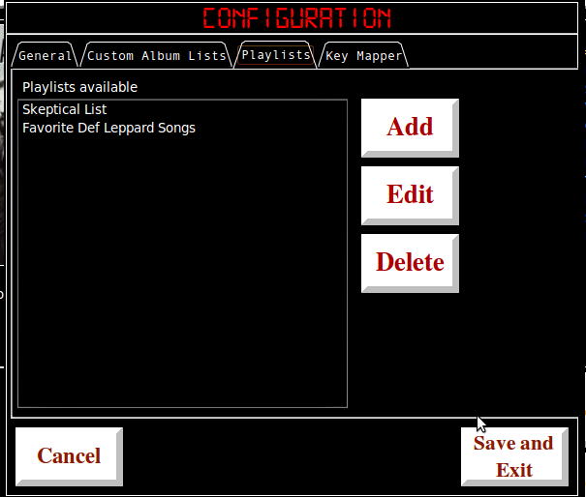

Editing a Playlist
To edit a Playlist, highlight it in the Playlist section of the Config screen and click Edit.

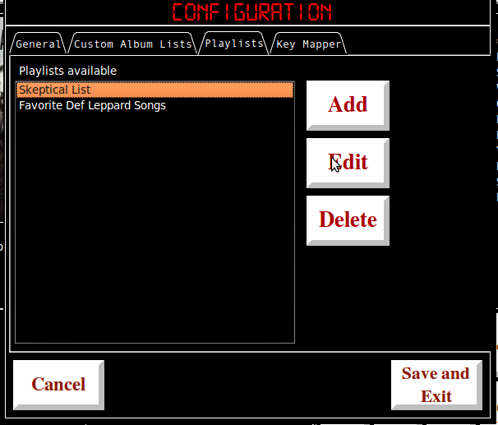
This will bring up the Add/Edit Playlist screen. Add and remove tracks, the same as if you were creating a list, and click Save. Make sure to click Save and Exit in the Config screen to save the changes to the playlists file.

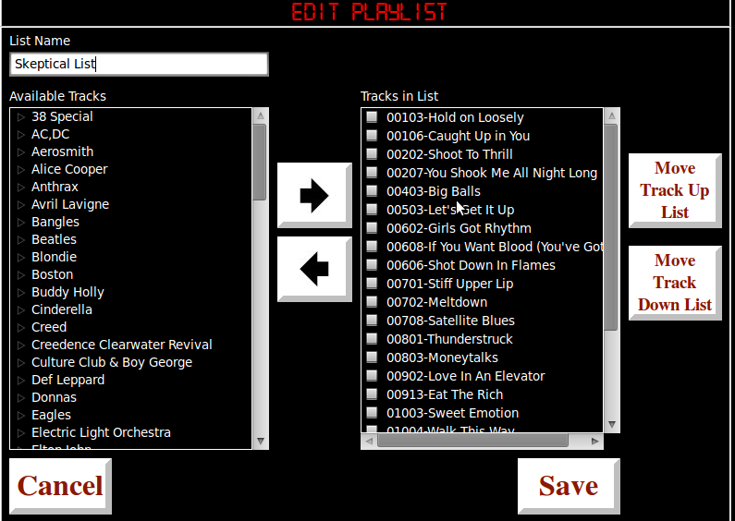
Loading a Playlist
To load a Playlist, click the Load Playlist button on the Options screen, or presst Ctrl-P on the keyboard. This will bring up the Load Playlist screen.

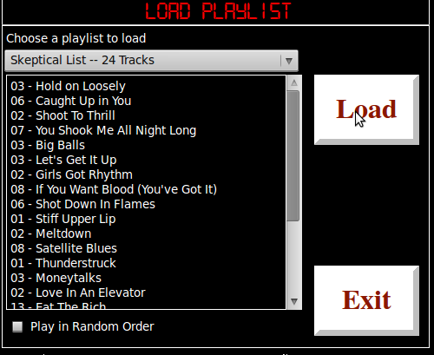

Choose the Playlist you wish to load from the drop down list. The tracks in the list will appear in the box underneath. This is just for verification, so you can verify you have the correct Playlist. Check "Play in Random Order" if you want to, well, play the tracks in random order (some of these are pretty staightforward, folks). Then click Load, and viola, all your tracks are loaded at once.

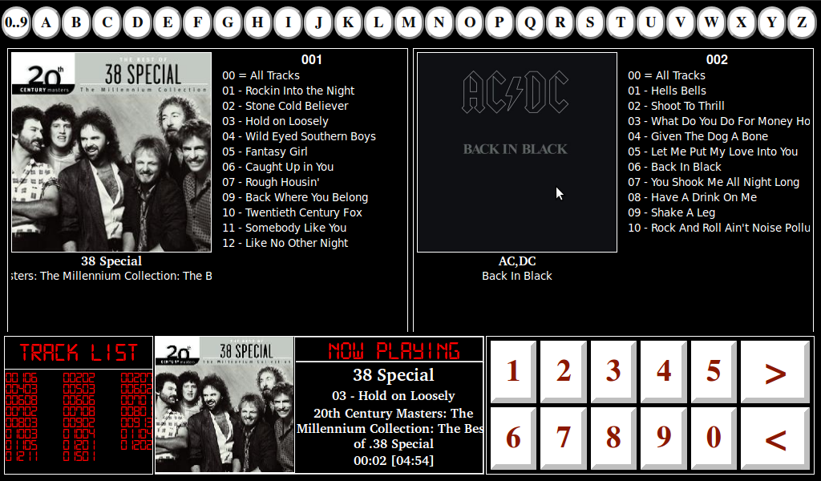

Adding a CD to Your Collection
The SKG Jukebox has a built-in CD ripper function so you can add new albums to your collection, without leaving the program. First, make sure you have an audio CD in the drive. Then, click Rip CD from the Options screen, or press Ctrl-R on the keyboard. This will bring up the Add CD screen.

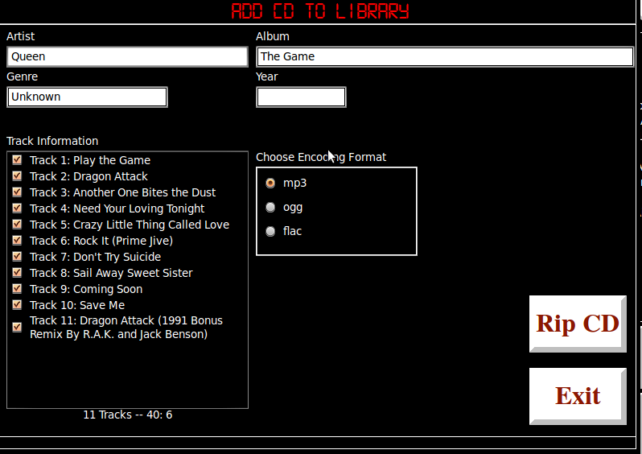
The CD ripper screen queries the freedb service for information about you album, and displays the artist, album name, genre and year in the boxes above. (If known. Sometimes freedb doesn't know the genre or year, as above) In the box on the lower left, you will see the tracks as a set of check boxes. By default, they are all checked. Uncheck any tracks you do not want to rip. (There are many reasons you might want to do this. For example, i love Lynyrd Skynyrd, but Free Bird makes me want to strangle an entire neighborhood, so i left thsat one off when i ripped their Best Of album. Also, some mixed media Cds contain movies, photos, or other data that the album ripping logic will choke on, so ou will want to uncheck those. The most popular examples of this are the Beatles remastered Cds, each with a Quicktime movie file). To the right of the track list, you will see 3 radio buttons for choosing the format. SKG Jukebox rips Cds to 3 formats: MP3s using LAME, as well as the free and open formas Ogg Vorbis and FLAC. Once you have chosen your format and unchecked any tracks you don't want, click Rip.

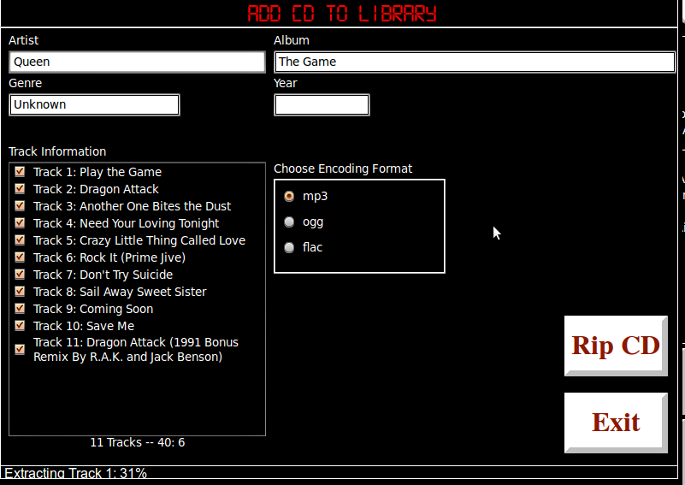
There are two stages to ripping a CD, extraction and encoding. Extraction rips the CD audio tracks from the disc, and saves them as uncompressed wav files, in the tracks subdirectory of SKG Jukebox. Encoding then takes that wav file, compresses it and encodes it in the format of you choice. Afterward, the temporary wav file is deleted, so as not to use up valuable hard drive space.

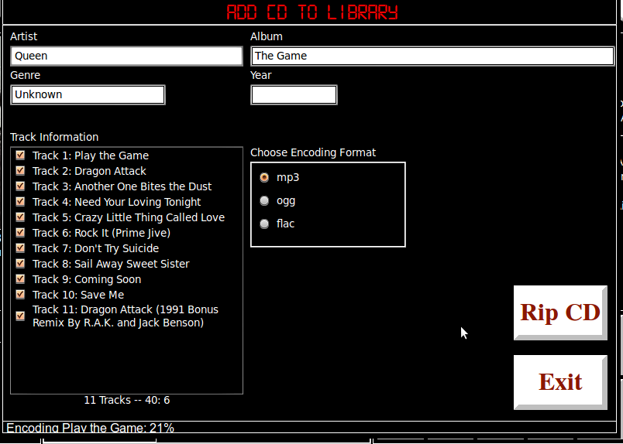
After all tracks are extractted and encoded, a dialog box will pop up asking if you want to rip another CD, or exit. Make sure you have a different disc in the drive before you click Import Another CD, or else the ripper will look up information on the current disc, and try to rip it again.

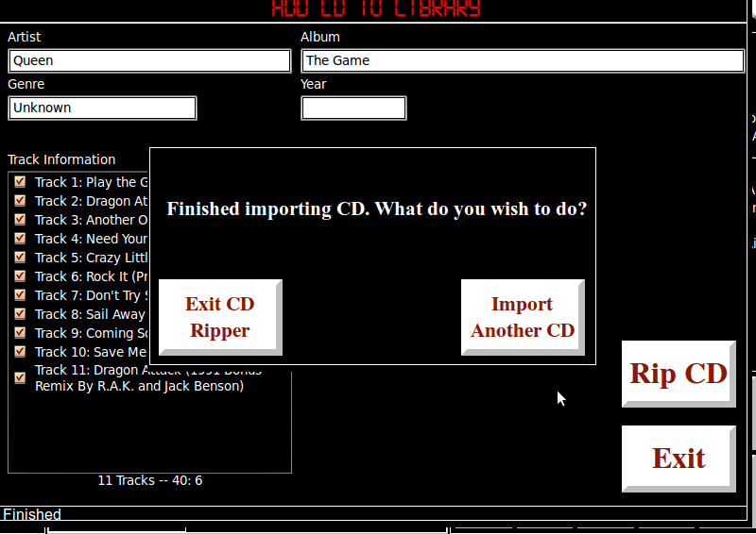

Adding Album Art
SKG Jukebox has two methods of obtaining, or changing, the album art for you collection.

Obtaining Art for a Single Album
To download art for a single album, click tha album panel, or enter the album number, as if you were selecting the album to add a track.

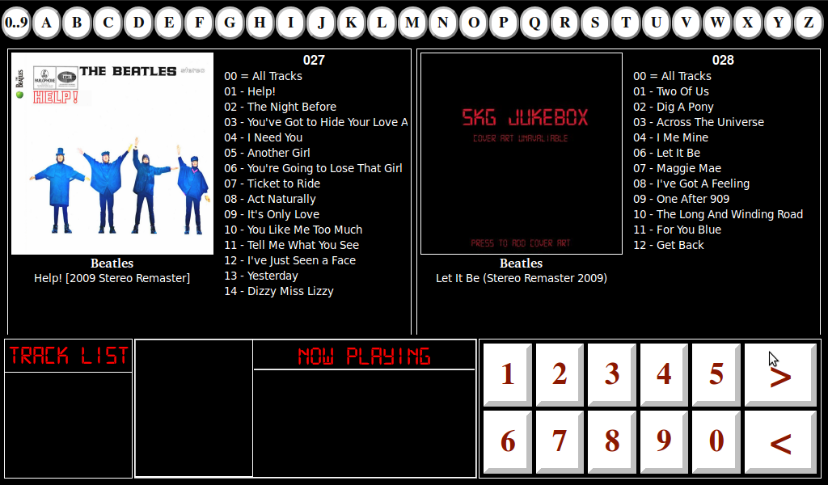

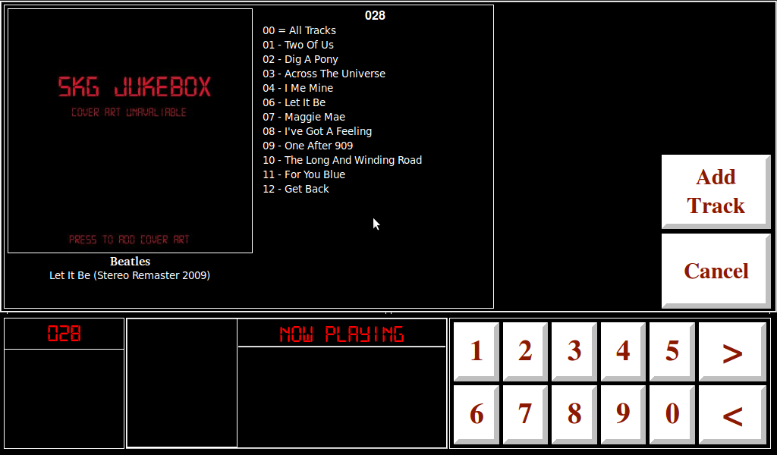
If the album has no artwork, you will see the defaukt graphic. Yes, I know it's ugly. I'm the Skkeptical Geek, not the Skeptical Graphic Artist. Click anywhere on the artwork, or lack thereof, to bring up the Album Art screen.

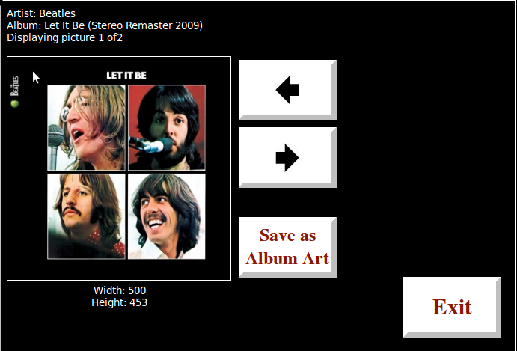
The Album Art screen will search various internet image archives for artwork matching the artist and album name. It will return several options. Ust the left and right arrow buttons to go through the various pictures. Underneath each picture, you will see the height and width of the image in pixels. Don't wory, the image will be scaled to fit the album panel, but higher resolution images usually scale better when you expand the album panel to full screen. When you get to the one you like, click Save as Album Art. You will now see the album art displayed on the main screen.

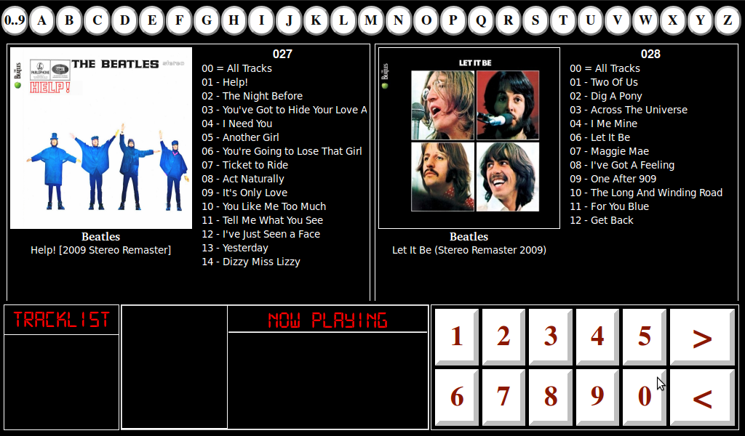

Adding Art for Several Albums
To add artwork for multiple albums, click the Album Art button on the Options screen, or press Ctrl-A on you keyboard. The Multiple Album Art screen will appear.

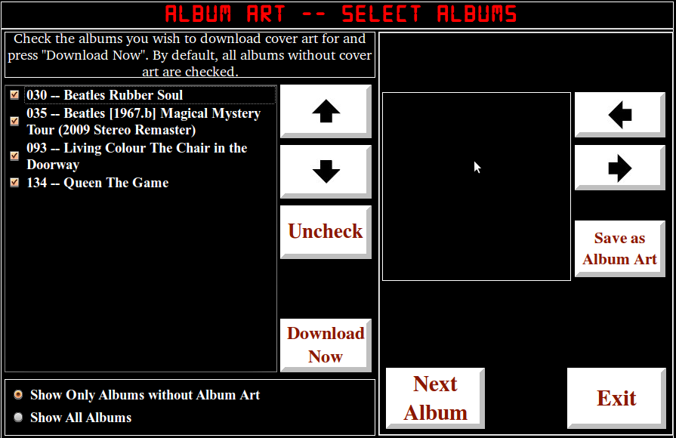
On the left, you will see a list of album names with check boxes. To the right of this, several buttons, and underneath, 2 radio buttons. The check boxes contain album information, the album number, artist and album names, of all the albums in your collection that do not have artwork associated with them. If, for some reason, you do not wish SKG Jukebox to sesarch for artwork for any of the albums on this list, uncheck the appropriate box. The up/down arrow buttons and the Check/Uncheck button are for touchscreen users to traverse the list, checking and unchecking albums. The radio buttons underneath switch the display from only albums without art, to all albums. If you have artwork for an album, but want SKG Jukebox to search for a replacement, choose Show All Albums, and check the albums for which you want to replace the artwork. Click Download Now to start downloading art for the first checked album in the list.

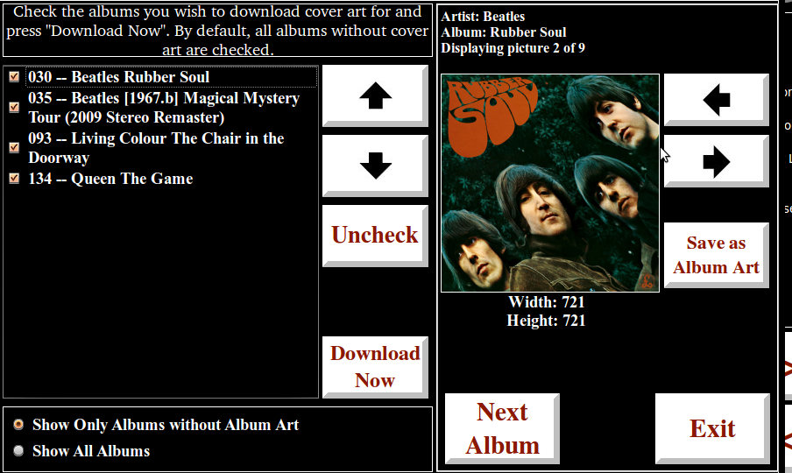
The same as if you were downloading art for a single album, SKG Jukebox will search the Internet and return a number of choices. Use the left and right arrow buttons to scro ll through them, then click Save as Album Art when you find the one you want. Then click Next Album to start searching for artwork for the next checked album in the list. Click Exit when finished.

Help Screen
Click the Help button on the Options screen, or press Ctrl-H
on the keyboard from the main screen, to access the Help screen. The help screen basically shows you this user manual. Touchscreen users can use the up and down arrow keys to scroll through the document.

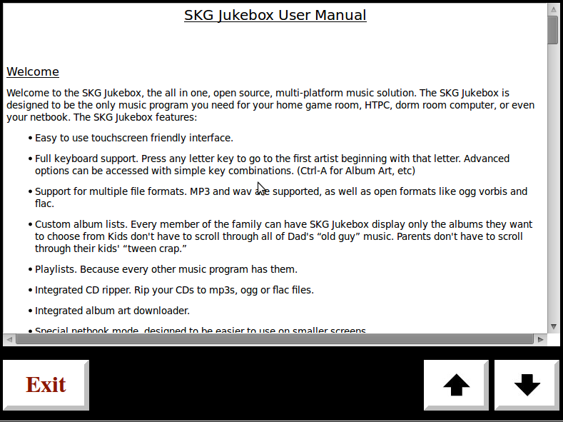

Keyboard Shortcuts
From the beginning, one of the design goals of SKG Jukebox was to be touchscreen friendly. The idea was that anything you want to do on the jukebox, you can do with a touch or a mouse click. And, with a few exceptions, such as giving a name to a new Playlist or Custom Album List, I think I've succeeded. The SKG Jukebox does, however, come with a full range of keyboard shortcuts, for those whos wish to do things that way. The following are the list of keyboard commands. Keep in mind that any of these can be remapped on the Key Mapper portion of the Configuration screen.

- 0 - 9 (Number keys) – Corresponds to the number buttons on the main screen.
- Left Arrow – Corresponds to the ">" button on the main screen.
- Right Arrow -- Corresponds to the "<" button on the main screen.
- A - Z (Letter Keys) – Corresponds to the letter buttons at the top of the screen.
- ~ (Tilde Key) – Corresponds to the 0..9 button at the top of the screen.
- Space – Pause/Resume playing current track.
- Enter – Adds the selected track to the list.
- Ctrl-A – Album Art Screen
- Ctrl-C – Clear all tracks, including the one currently playing.
- Ctrl-G – Configuration screen.
- Ctrl-H – Help screen
- Ctrl-L – Load Custom List Screen
- Ctrl-N – Play next track in list.
- Ctrl-O – Options Screen
- Ctrl-P – Load Playlist Screen
- Ctrl-R – Album Ripper Screen
- Ctrl-T – Track List Screen
- Esc – On main screen, exits jukebox. On any other screen, exits that screen.

FAQ
The title of this section is a little misleading. Since this is a new product, I haven't actually had any questions asked yet. So here are some questions I think you might ask, based on my experiences, and those of the few people who have seen this in development.

Q—What kind of music files will SKG_Jukebox play?
A—At the moment, SKG_Jukebox will play mp3 files, as well as the free and open ogg and flac formats. I may add support for additional file types later, if requested. I do not support aac at the moment, because of objections to digital rights management. If I can figure out how to support only non-DRMed aac files, I may support it.

Q--What kinds of file formats cn the album art be?
A—SKG_Jukebox will display bmp, gif, jpeg or tiff album art files.

Q---My tracks don't play. What gives?
A—Probably a codec issue. SKG_Jukebox doesn't really have a decoder, per se. It uses Qt's Phonon architecture, which in turn relies on the underlying OS to determin what it can play. Essentially, if the OS doesn't recognize the file, SKG_Jukebox can't play it.
For Linux users, it is probably mp3 files you can't play. A lot of Linux distributions, including popular ones like Ubuntu, don't come with mp3 support built in, because mp3 is a patented file format. Adding it isn't difficult, though you will have to get familiar with a command line. Just do a Google search for the name of your distribution, plus the phrase "mp3 support". If this problem perists, check the settings for your phonon backend in System Settings.
Conversely, Windows does not come with support for ogg or flac files, because free and open file formats make Microsoft executives cry. Again, do a Google search for "Ogg Windows" or "Flac Windows" to find out how to support those files in Windows.

Q—I am running in netbook mode, and the main screen doesn't display correctly.
A—The netbook mode is really designed for netbooks. It runs best at 1024 * 600. It doesn't generally scale well below that. If you are running 800 * 600 or below:
A) Why?
B) Run in normal mode. It scales well down to that resolution, and very well at 1024 * 768 or above.

Q—Where does the artwork in the Download Album Art screen come from?
A—The album art screens do a Google and Yahoo image search using the artist and album name, return the top 5 results from each site, and put them in a list. There may be some overlap, or there may not be 5 good matches, so the list may contain less than 10 items. I know there are better sources out there. Amazon, for example has greater breadth, and some of the web sites that specialize in album art have higher quality images. However, Amazon's api (application programming interface) is incompatible with open source, and the specialty sites generally don't want applications using their content, unless they are web apps linking to their site. The Album Art function is designed to be easy to use, and retrieve a reasonable quality image most of the time, or "close enough for government work" as my grandfather, The Skeptical Grandpa, used to say. It may not work for obscure bands but basically, if you can buy the CD at Best Buy, SKG Jukebox can find the album art for it.

Q—I want to control the bit rate, quality settings, or one of the thousand other lam/ogg/falc options when ripping a CD.
A—Not going to happen. The album ripper function is designed to be simple, not comprehensive. It will produce good quality files at a reasonable file size. If you need more control over the extraction and encoding process, there are numerous other programs for all platforms that can provide this. See the above "close enough" quote.

Q—Hey, I just ripped this .38 Special album, and it doesn't show in my library. What gives?
A—You are probably on a Linux system. The period (.) at the beginning of the band's name is interpreted by Linux to mean hidden file or directory. Go into your music directory. Make sure to tell your file manager to show hidden files. Rename the artist directory, removing the period at the beginning. The artist and all the albums will show up as normal.

Q—I tried ripping one of the new Beatles remastered albums. It took forever, and the last track is junk.
A—The new Beales remastered albums contain a data track at the end, actually a Quicktime movie file about the making of the album. Te cd ripper screen does not know how to extract or encode this kind of file, so the results can be unpredictable. It also doesn't know how to distinuish between audio and other tracks when it is reading the CD. Just uncheck the last file before ripping the CD. Similar things can happen with other mixed media discs, so make sure and go over the track list before clicking the Rip CD button.

